**Operation**

1. Plug in power/switch on power.

LED:

Solid Orange: Initializing SD.

Blue: Ready to start recording data or be turned off.

Blinks Orange: The SD card is either not plugged in OR failed to initialize. Plug in the SD card if it was missing and press RESET in either case.

1. Once blue, press the MODE button.

LED:

Green: Has a fix and is recording data.

Red: Doesn’t have a fix and is not recording data. It will start recording data when finds a fix.

Press the MODE button again to stop logging data. LED should turn blue.

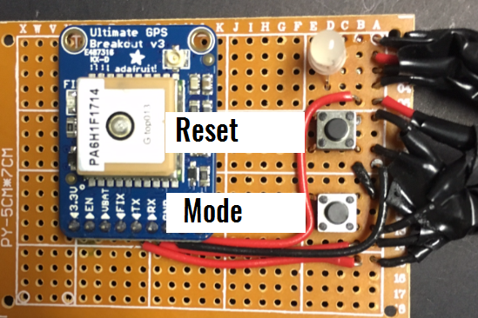

Notes:

* **If the SD card is removed at any point while the system is on (any color LED) , you must press RESET before you start logging again. If reset is not pressed, data will NOT be logged even if the LED is green/red.**

* Pause GPS by leaving the GPS on at a blue state.

It will consume nearly as much power as if it was logging so turn the system off its not in use for extended amounts of time.

* If there is a backup battery, the GPS will not lose fix data when it is powered off (led turns green quickly). If there is no backup battery, the GPS will lose fix data. This means that it may take minutes before it can start logging data.

* The GPS module has a onboard red LED. It blinks quickly if it is trying to find a fix and once every 15 seconds if a fix has been found.

**Retrieving Data**

From File

[SS of file in folder]

[SS of opened file]

Data is delimited by "|" in the order of:

Log # | Time(H:M:S)| Lat&Long (Deg) | Speed (Km/h) | Altitude | # Satellites

To excel

Select all and copy data over to a cell in excel.

Use "Text to Columns" feature to split data into columns.

[Insert SS's]

**Data**

Log #: Starts incrementing from 1 when powered on or reset. If the system is not reset and just paused, it will not reset to 1 but resume from the last # it left off at.

Time: In GMT which is 5 hours ahead of EST.

Latitude and Longitude: In degrees. This format can be used by google maps.

Speed: Km/h